**Planar Quad Code, Plots, & Figures**

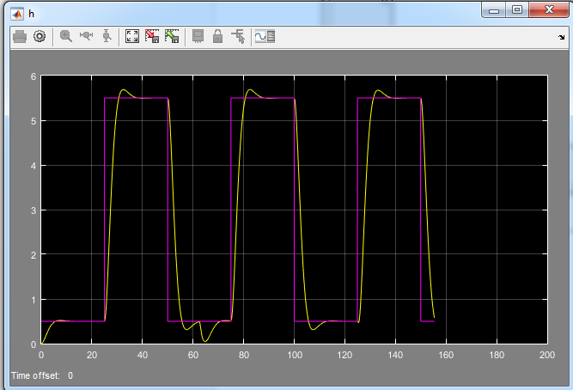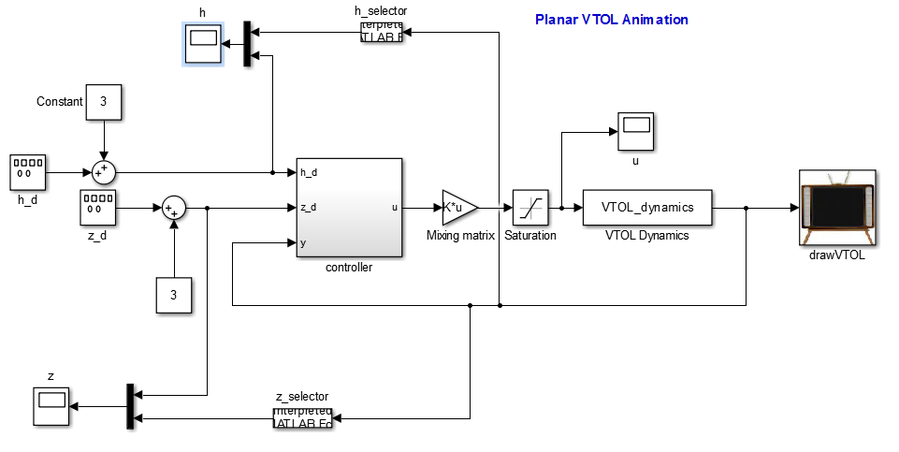

h response plot

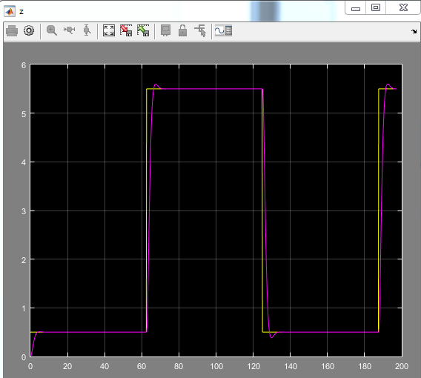z response plot

STATE SPACE PARAMS

%%%%%%%%%%%%%%%%%%%%%__State Space Controller Params__%%%%%%%%%%%%%%%%%%%%

%Desired performance characteristics

wn_h = 1*sqrt(P.kp_h/(P.mc+2*P.mr));

wn_th = 1*sqrt(b0*P.kp_th);

wn_z = 1*sqrt(b1*P.kp_z);

zeta_h = 1*0.707;

zeta_th = 1*0.707;

zeta_z = 1*0.707;

char_poly_h = [1, 2*zeta_h*wn_h, wn_h^2];

des_poles_h = roots(char_poly_h);

char_poly_z_th = conv([1, 2*zeta_z*wn_z, wn_z^2],...

[1, 2*zeta_th*wn_th, wn_th^2]);

des_poles_z_th = roots(char_poly_z_th);

%State space matrices

%%%%%%%%%%Up and Down%%%%%%%%%%%%%

A_h = [0 1;0 0];

B_h = [0;(1/(P.mc+2*P.mr))];

C_h = [1 0];

D_h = [0];

%Check to see if system is controlable

if rank(ctrb(A_h,B_h)) ~= 2, disp('System Not Controllable');end

P.K_h = place(A_h,B_h,des_poles_h);

P.kr_h = -1/(C_h(1,:)*inv(A_h-B_h*P.K_h)*B_h);

%%%%%%%%%%%Side to Side%%%%%%%%%%%%%%%%

A = [0 0 1 0;0 0 0 1;0 -P.Fe/(P.mc+2*P.mr) P.mu/(P.mc+2*P.mr) 0;...

0 0 0 0];

B = [0; 0; 0; 1/(P.Jc+2*P.mr*P.d^2)];

C = [1 0 0 0;0 1 0 0];

D = [0; 0];

%Check to see if system is controlable

if rank(ctrb(A,B)) ~= 4, disp('System Not Controllable');end

P.K = place(A,B,des_poles_z_th);

P.kr = -1/(C(1,:)*inv(A-B*P.K)*B);

**VTOL STATE SPACE CONTROLLER FUNCTION**

function output = Planar_VTOL_SSctrl(in,P)

h_d = in(1);

z_d = in(2);

z = in(3);

h = in(4);

theta = in(5);

t = in(6);

%Digitally compute the derivatives zdot and thetadot

persistent zdot

persistent z_dl

persistent thetadot

persistent theta_dl

persistent hdot

persistent h_dl

%Initialize persistent variables at simulation start

if t<P.Ts,

zdot = 0;

z_dl = 0;

thetadot = 0;

theta_dl = 0;

hdot = 0;

h_dl = 0;

end

zdot = (2*P.tau - P.Ts)/(2*P.tau + P.Ts)*zdot...

+ 2/(2*P.tau + P.Ts)*(z - z_dl);

thetadot = (2*P.tau - P.Ts)/(2*P.tau + P.Ts)*thetadot...

+ 2/(2*P.tau + P.Ts)*(theta - theta_dl);

hdot = (2*P.tau - P.Ts)/(2*P.tau + P.Ts)*hdot...

+ 2/(2*P.tau + P.Ts)*(h - h_dl);

z_dl = z;

theta_dl = theta;

h_dl = h;

%Construct the states

x_h = [h; hdot];

x = [z; theta; zdot; thetadot];

%Compute the state feedback controller

F = sat(-P.K_h*x_h + P.kr_h*h_d + P.Fe, 2*P.fmax);

T = sat(-P.K*x + P.kr*z_d, P.taumax);

output = [F; T];

end

% saturation function

function out = sat(in,limit)

if in > limit, out = limit;

elseif in < -limit, out = -limit;

else out = in;

end

end

**Ball and Beam Code, Plots, & Figures**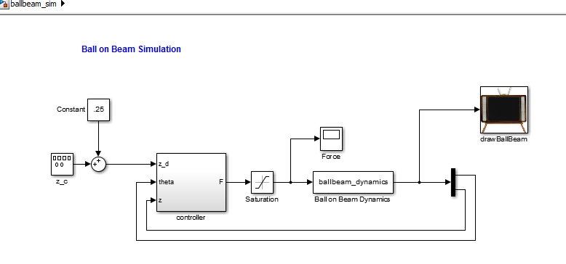

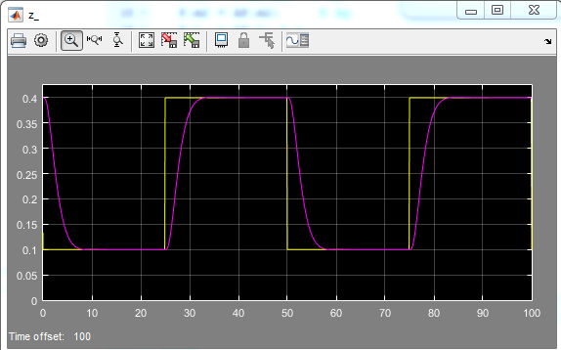

z response plot

STATE SPACE PARAMS

%%%%%%%%%%%%%%%%%%%__Sate Space Model Params__%%%%%%%%%%%%%%%%%%%%%%%%%%%%

%desired response parameters

wn_th = 1.5*2.652;

wn_z = 1*.6991;

zeta_th = 0.7;

zeta_z = 0.9;

%state space matrices

A = [0 1 0 0;0 0 -P.g 0;0 0 0 1;...

(-P.m1*P.g)/((P.m2*(P.L^2)/3)+P.m1*ye^2) 0 0 0];

B = [0; 0; 0; P.L/((P.m2*(P.L^2)/3)+P.m1*ye^2)];

C = [1 0 0 0; 0 0 1 0];

D = [0; 0];

%gains for pole locations

charpoly = conv([1, 2*zeta_z*wn_z, wn_z^2],...

[1, 2*zeta_th*wn_th, wn_th^2]);

des_poles = roots(charpoly);

%Check to see if system is controllable

if rank(ctrb(A,B)) ~= 4,

disp('System Not Controlable');

else

P.K = place(A,B,des_poles);

P.kr = -1/(C(1,:)*inv(A-B*P.K)*B);

end

**BALL AND BEAM STATE SPACE CONTROLLER FUNCTION**

function F = ballbeam_SSctrl(in,P)

z_d = in(1);

z = in(2);

theta = in(3);

t = in(4);

%use digital differentiator to find zdot and thetadot

persistent zdot

persistent z_d1

persistent thetadot

persistent theta_d1

%reset persistent variables at simulation start

if t < P.Ts

zdot = 0;

z_d1 = 0;

thetadot = 0;

theta_d1 = 0;

end

%compute the digital derivatives

zdot = (2*P.tau-P.Ts)/(2*P.tau+P.Ts)*zdot...

+ 2/(2*P.tau+P.Ts)*(z-z_d1);

thetadot = (2*P.tau-P.Ts)/(2*P.tau+P.Ts)*thetadot...

+ 2/(2*P.tau+P.Ts)*(theta-theta_d1);

z_d1 = z;

theta_d1 = theta;

%Construct the State

x = [z; zdot; theta; thetadot;];

Fe = P.m2*P.g/2; %+ P.m1*P.g*z/P.L;

%Compute the State Feedback Controller

F = sat(-P.K*x + P.kr*z_d + Fe, P.Fmax);

end

% saturation function

function out = sat(in,limit)

if in > limit, out = limit;

elseif in < -limit, out = -limit;

else out = in;

end

end